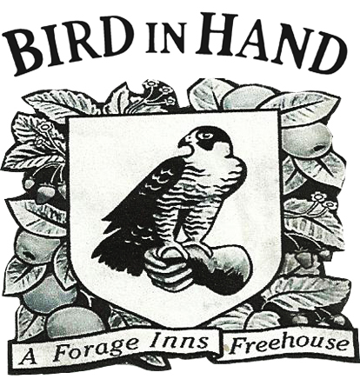

**Sunday Lunch 2nd June**

**Hendrick’s gin & cucumber £5.10**

**Smoked cod’s roe & beer bread £3.50**

**Potted old spot, mustard & pickles £5.00**

**Wye valley asparagus with an egg from down the road £6.00**

**Provencal fish soup £6.00**

**Brown crab meat on toast £5.00**

**Fried Cornish haddock, chips & tartare sauce £11.00**

**Artichokes, broad beans, mint & goats curd £12.00**

**Roast Rib of middle white pork, crackling & apple sauce £12.50**

**Roast rump of Hereford beef, horseradish & Yorkshire pudding £14.00**

**Bakewell tart & damson ripple ice cream £4.95**

**Sticky toffee pudding & butterscotch sauce £4.95**

**Buttermilk pudding, strawberries & shortbread £4.95**

**Poached chocolate cake & salted caramel £4.95**

**Barkam blue & oat cakes £4.00**

**All food is hand made on the premises from locally sourced ingredients.**

**All food may contain some traces of nuts.**

**A discretionary 10% service charge will be added to all tables.**